Technical Report

Forensic File Signature Analysis

NYIT Vancouver

INCS-712: Computer Forensics

Professor: Habib Louafi

Group 1

Forensic File Signature Analysis

- INTRODUCTION

The forensic file signature analysis is more about the data hiding forensics. It is a process whose job is to match the suspected data type with the database. Many tools could perform this comparison process. The tools used in this report are HxD Hex Editorin and HexBrowser in Windows OS. This report aims to introduce the analysis process of the file signature, how to find the correct application to associate them, and the recovery process.

- PROCEDURE

- Manually Analyze the file signatures with HxD Hex Editorin in Windows OS
Every file has a unique hex signature and will identify the type of the particular file regardless of changing, deleting, or hiding the extension. To figure out its appropriate file extension File signatures to aid with the restoration process of the unreadable files. Signature analysis is a process where file headers and extensions are compared with a known database of file headers and extensions to verify all files on the storage media and discover those that may be hidden. So, we’ll manually analyze the header and trailer of these files by HEX Editor to identify their type.

- Try to hide a confidential PDF file as JPG and stored it in a folder of pictures.

Figure 1

Figure 2

- This myCat.jpg can’t open by media application. Then, open the file in HxD Hex Editorin shown in Figure 4, and we can find the header.
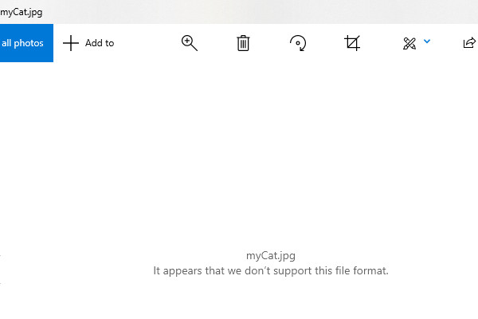
Figure 3
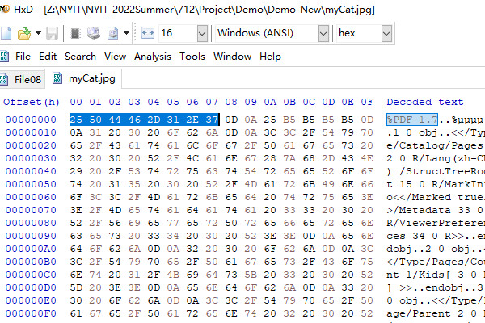
Figure 4

- Copy the group of bytes highlighting over there and go to the website to find its associate file extension.
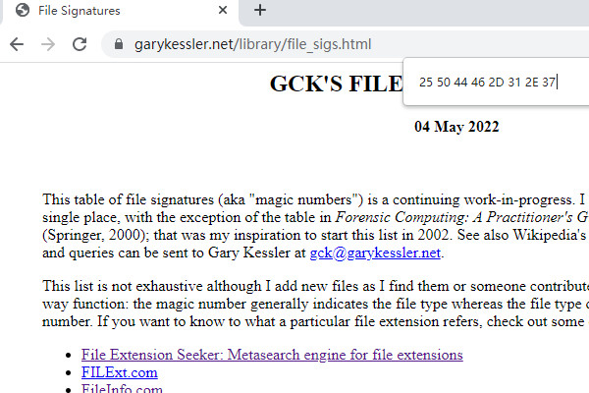
Figure 5
- Start backspacing until it finds results. In Figure 6, the four bytes are known as pdf format, and its file description is the same as in HxD Hex Editorin in Figure 4. Additionally, we compare the trailers at the end of the hex shown in Figure 7.
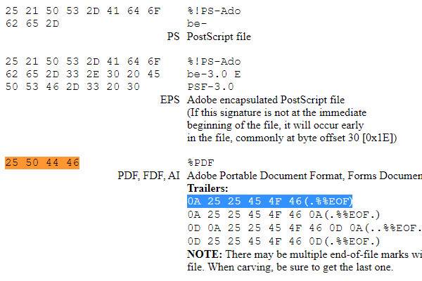
Figure 6
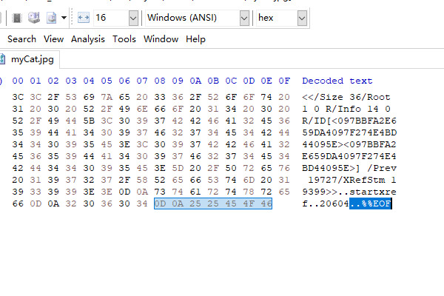
Figure 7

- Change the file extension to “.pdf” and try to open it in word.
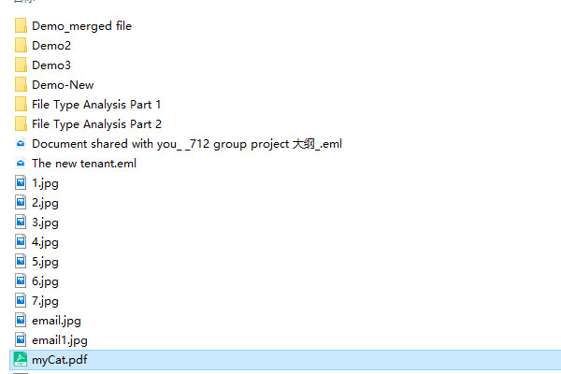
Figure 8

- Compare the result in both pdf and in HxD Hex Editorin.
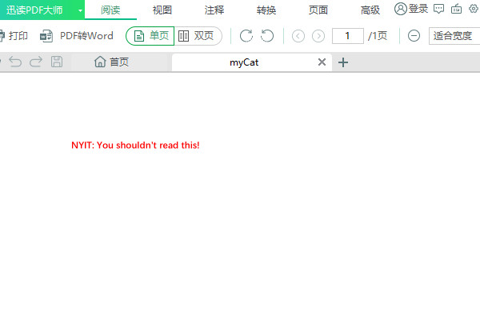
Figure 9

- Automatically Analyze the file signatures with HexBrowser in Windows OS
HexBrowser is a freeware that identifies file types. It now recognizes more than 1000 file formats by looking for signatures inside the files. Hence, we don’t need to determine the file's extension by checking every file's signature. We will automate the analysis process using HexBrowser in Windows OS in this part.

- Open the HexBrowser and choose the file that needs to be analyzed. We can find the file type shown in Figure 10.
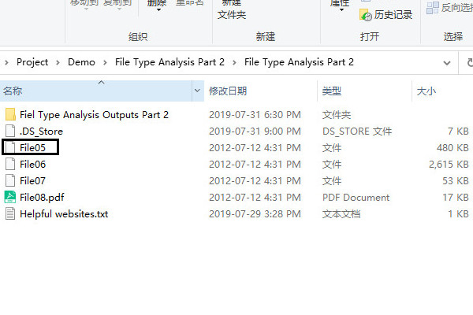
Figure 10

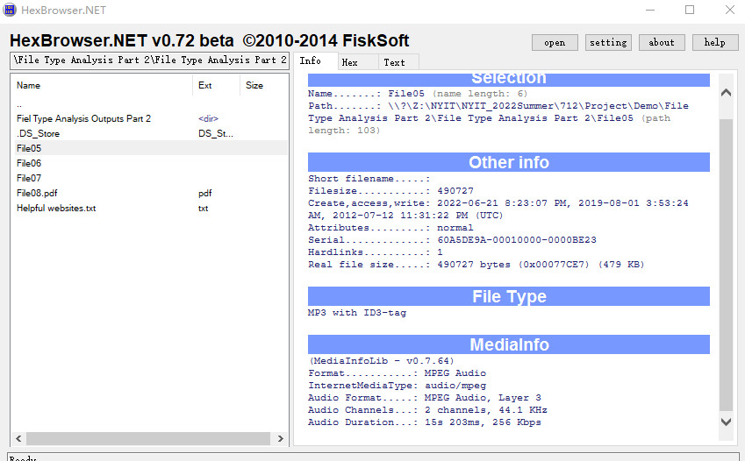
Figure 11
- Change the file extension to “.mp3” and try to open it in any audio application.
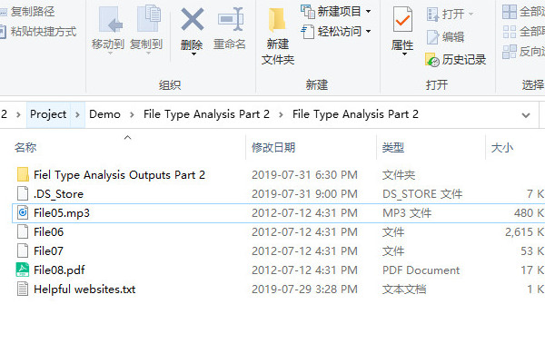
Figure 12

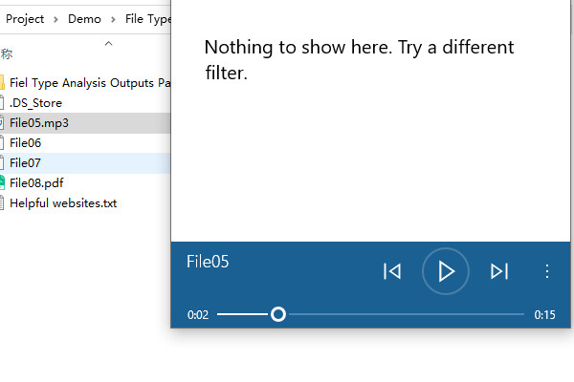
Figure 13

Reference

[1] Nihad Ahmad Hassan and Rami Hijazi. 2016. Data Hiding Techniques in Windows OS: A Practical Approach to Investigation and Defense (1st. ed.). Syngress Publishing.

